Tasks
- Create enough test cases to test the functionalities described in the SRS.
- Save those test cases in simple files (TXT or XLS/X) or a test management system of your choice. Add screen shots to your test cases if necessary. Upload all the files as a single zip file in SoftUni system, in the case a test management system is used, please provide access and some screenshots of the test cases.
- Set correct priority to your test cases depending on the functionality importance. Most important test cases that has to be run are the highest priority, the least important test cases are the lowest priority.

Resources
The project is located at: https://www.animal.co.uk/

Software Requirements
- Introduction
  - Purpose
The purpose of this document is to present a detailed description of Online Web Store application. It will explain some of the key features at very high level.
  - Scope
The document will cover the basic functionality on high level regarding the Online Store. The user-management system, the Orders creation and operation and its respective details. The administrative part – what the special user (Administrator) is not in the scope
- Overall description
  - System environment
The Store has two active actors and one cooperating system. All of them are accessing their parts from the internet. Also both of the can access some of the basic operations over the orders. Both can create order. Only the registered one can edit its own orders, add and remove details from it, rate products as well and details regarding payments, address of delivery and add products as favorites.
  - Vocabulary
    - Product page ​– A product page is the main information block regarding a product. It consists of the Product Name in the middle. Like and Add to cart buttons. Should contain Product price in GBP, also if discount is available. And a cover image/s on the very right side, size options and available colors. Additional information about the product can be seen on the right. In order to improve our sells, we should suggest what are products the rest of the users bought in a “People who bought this item also bought” section. Here user will get quick image links to other products.
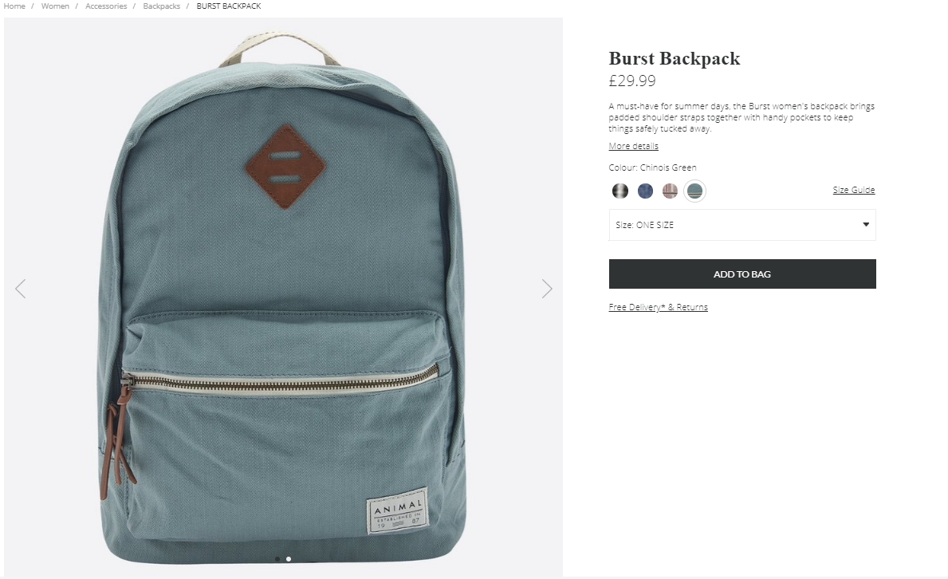
    - Quick view​ – A simple view is the main short information block regarding a product. It consists of the Product name in the right side. The picture itself at the left. Should contain Product price in USD, also if discount is available, available sizes and colors. Like and “Add To Cart” buttons.
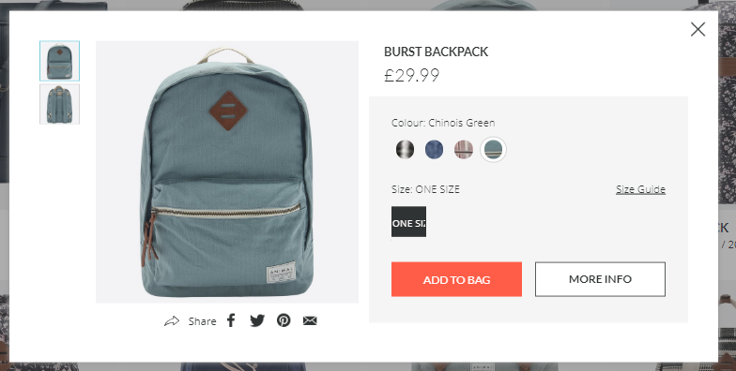
    - Catalog categories – a simple list of product, containing 4 products per line. Each product has it’s name, size and price.
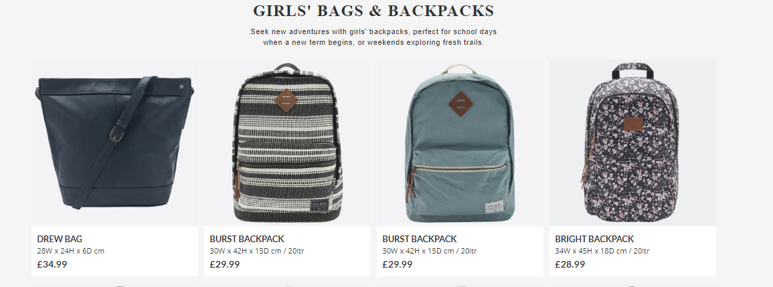
  - Functional requirement specification
    - Use Case 1 (Accessing the system) The system is accessed through the internet from its initial URL. It loads header, navigation bar and a home page.
    - Use Case 2 (Navigation bar) The navigation bar has navigational hyperlinks to the Home, Product category, Store finder, Login and Registration option, All Products. As well as it should have navigation to the Checkout and Search.
    - Use Case 3 (Home page)
The home page shows the Product blocks in random order in a slider section. Clicking on the banners leads to the relevant category with products. Latest products section should be available at the bottom.
    - Use Case 4 (Products Category Page)
Information regarding the sub-categories is shown as links (e.g. Jeans, T-Shirts) in the navigation pane, where user can choose where to go next. Display functionality offers the possibility to show how products are shown, based on the following views:
- Size
- Color
- Price
The respective information regarding the products is shown on the page in a form of random results. Simple view should display the products. When the filter is applied (sub-category) the page should display the respective products found. If the input data is invalid, a respective error box is shown, indicating that products are “Not Found” and “Apologies, but the page you requested could not be found. Perhaps searching will help.” tip.
    - Use Case 5 (My account)
Clicking on the My Account hyperlink from the header navigates to the My account page. Page lists the available sections:
- Order History
- Favorites
- Address
- Edit profile options
    - Use Case 6 (Search)
Clicking on Search from in the header allows for product finds by given keywords. If we have such products, we should show a list with the results. If no product is found, we should display error message stating that “Sorry, but nothing matched your search criteria. Please try again with some different keywords.”

